3-Steps To Unlock Your Information Advantage To Land Lucrative Clients

Nicolas Cole
May 06, 2025

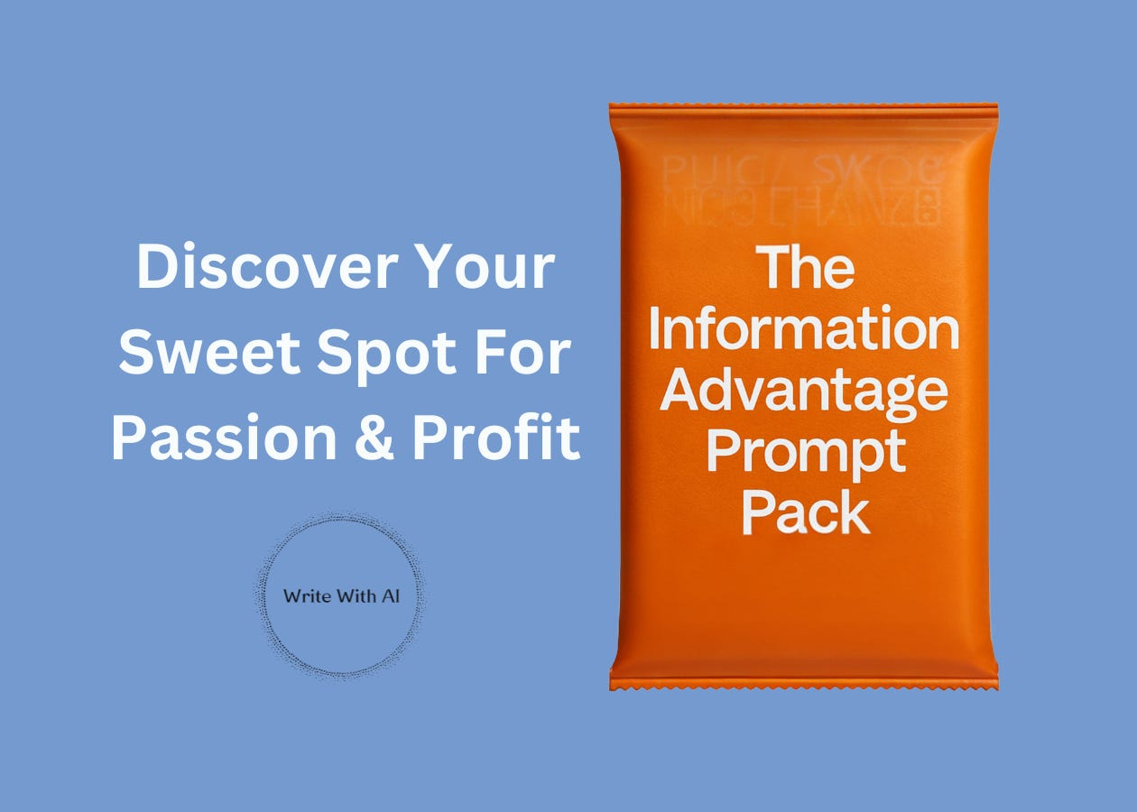

Today, we're diving into the most important part of becoming a high-paid writer:
Your Information Advantage
Remember, your Information Advantage is the knowledge you have that most writers don't—and consequently what clients will pay premium rates to access.
Here’s the problem:
We tend to undervalue what comes naturally to us.
Because you think "everyone must know this." And so you ignore what you know and instead you run off on a never-ending niche hunting extravaganza to find an undiscovered idea worth millions that’s “out there somewhere.” No-doubt those ideas do exist.
But there’s a much easier path to making money with your writing. Especially when you’re already sitting on a goldmine of valuable knowledge!!
All you have to do is tap into it.
So let's uncover yours right now.
Step 1: Get Insanely Specific About Every Experience, Skill & Interest You Have
First, you need to get everything out of your head and onto paper.
Brain dump all your knowledge.
Make separate lists for:
- Work experience: Every job, role, and project you've completed
- Educational background: Formal degrees, certifications, and courses
- Hobbies & interests: Things you do for fun (ultrarunning, yoga, reading gothic horror)
- Life experiences: Challenges you've overcome, transitions you've navigated
- Skills you've developed: Both professional and personal
The key is being ridiculously specific.
Most people make the mistake of being far too general here, thinking things like "I've worked in sales for 10 years" or "I've been in finance." Instead, you want to be more specific. For example, "You built capitalization tables for Series B SaaS companies using Carta."
The devil is in the details.
And that's where your Information Advantage lives.
Step 2: Catalog Your "Weird" Knowledge Combinations
Everyone has unique knowledge combinations that make them even more valuable.
And the weirder the combination, the more valuable it can be.
Why? Because strange knowledge pairings create perspectives no one else has.
Here's how to find yours:
- List your top 3 professional skills
- List your top 3 personal interests or hobbies
- Write down any "random" knowledge areas you have (maybe you know a ton about 80s music, houseplants, or fantasy football)
Now look for the unusual combinations.
Maybe you understand both Facebook ad campaigns AND CrossFit.
Or you know about both financial planning AND sustainable living.
Or coding AND romance novels.
These weird combinations are where you’ll find an exponential advantage.
Because while there are thousands of Facebook ad experts and thousands of CrossFit enthusiasts, there are very few people who deeply understand both worlds.
And guess what? CrossFit gym owners would kill to work with a Facebook ads specialist who actually understands their unique challenges.
The weirder your combination, the less competition you'll have.
Step 3: Use ChatGPT As An Information Advantage Mirror To Find Your Ikigai

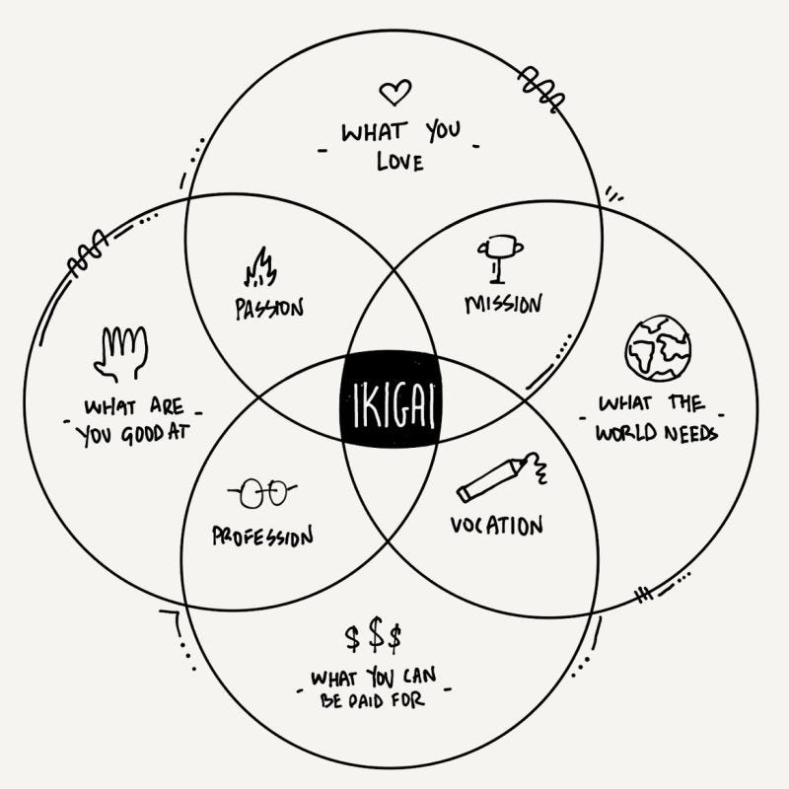

This is where the prompt comes in.
Copy and paste the prompt below into ChatGPT, and let it interview you.
Be honest. And most importantly, be specific.
Because ChatGPT will:
- Map out niches where you have a natural advantage
- Uncover patterns in your knowledge you're too close to see
- And help you connect dots between seemingly unrelated experiences
The key here is to answer each question fully before moving to the next one.
Don't rush this process—it's the foundation of your premium writing career. When you're done, ChatGPT will give you an "Ikigai" report showing where your knowledge, passion, and market opportunity overlap. If you're not familiar, Ikigai is a Japanese concept meaning "reason for being."
It sits at the sweet spot where four elements converge:
- What you're good at (your skills)
- What you love (your passions)
- What the world needs (market demand)
- What people will pay for (monetization potential)
The middle is your “Ikigai.”
ChatGPT will help you find it.
And suddenly, you'll see exactly where to focus your writing efforts.
Here’s the prompt:
You are an elite business positioning strategist who has helped 500+ entrepreneurs identify their unique "Information Advantage" - the specialized knowledge that positions them to command premium rates in their market.

I want you to interview me and help me uncover my Information Advantage - the intersection of my specialized knowledge, expertise, passions, and personal interests that gives me competitive edge with high-value clients.

Here’s how I want you to run the interview:

Ask ONE question at a time, waiting for my response before proceeding.

Focus on uncovering:
- Jobs I've worked
- Hobbies I've started
- Goals I've reached
- Skills I've built
- Experiences I've had

Begin with broad questions about my professional background, then progressively explore my hobbies, goals, skills, and experiences.

Your tone should be curious, conversational, and focused—like a mix of a journalist and a strategist.

You ask follow up questions to help me clarify my answers.

Don’t summarize my answers.

Ask me questions until I tell you to stop.

Then summarize my Information Advantage.

Give me:
- A list of niches I understand
- An explanation of why I have an edge in each space.
- An "Ikigai" report with insights for each intersection and sweet spot.

Let’s begin whenever you’re ready.
If you follow the 3 steps above, you should have a much clearer picture of your Information Advantage.
Tomorrow, we'll cover exactly how to find the perfect clients who need your specific expertise (and are willing to pay top dollar for it).
But for now, I want you to sit with this information and really own your advantage. Because in a world where everyone's fighting to be a "good writer," you're playing a completely different game.
Chat soon,
—Dickie & Cole

